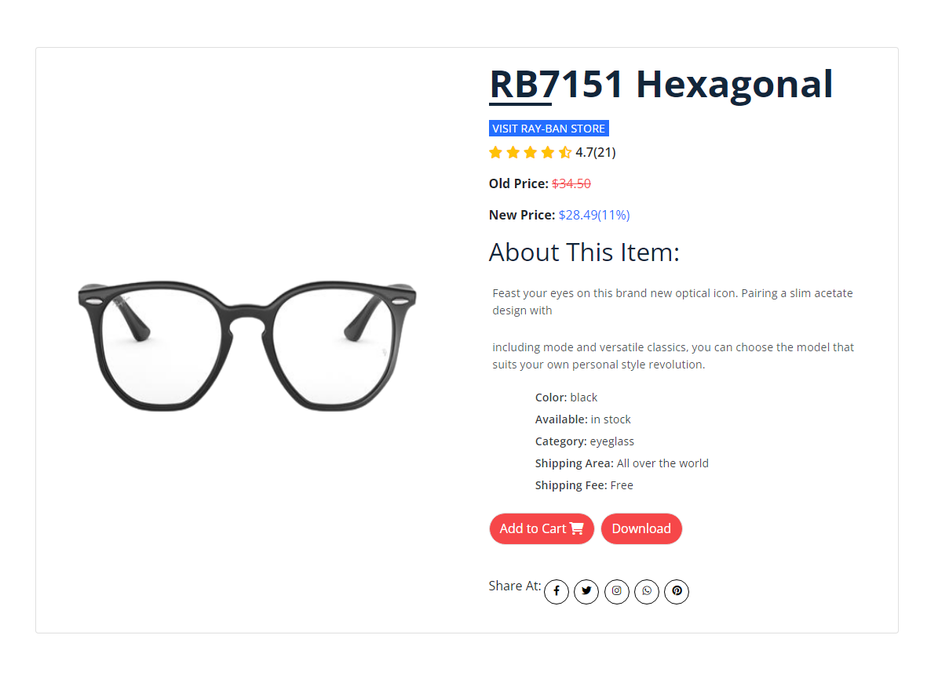
Feast your eyes on this brand-new optical icon. Pairing a slim acetate design with the hexagonal shape you love; the RX 7151 is a potent combination of form and function. The perfect style for those with high negative prescriptions, the acetate rim wire does a great job of hiding thick lenses. They’ll also work well with progressive lenses or any other shaped lens. Pick up the RX7151 in 1 of 8 colors, including black and Havana full frame, as well as striped Havana on the front matched with colored bilayer temples.
Product Details

